**Major Project Report**

On

**Whats’app Clone**

Submitted By

**Sanjay B**

At



**No.13-14, 2nd floor, Kothnur Main Rd,JP Nagar 7th Phase, Bengaluru, Karnataka 560078**

**Guided by: Lekha Savale Ma’am**

**Date: 30 October 2024**

**Abstract**

The WhatsApp Clone Project is a front-end application built using HTML, CSS, and JavaScript, designed to emulate the basic interface and functionality of WhatsApp. This project aims to provide a realistic chat experience, focusing on essential features such as a responsive user interface, message display, and temporary data storage.

The project includes a WhatsApp-like layout, with a sidebar for contacts and a main chat window where users can type and send messages. Each message displays with a timestamp, offering a basic simulation of a real chat interface. The responsive design adapts to both mobile and desktop screens, achieved through CSS media queries, ensuring a seamless user experience across devices.

JavaScript powers the interactive aspects of the application, handling user actions, message display, and local storage for temporary data persistence. While the project lacks backend support, it demonstrates a foundational understanding of front-end development, UI design, and JavaScript-based interactivity.

This project provides a solid basis for future enhancements, such as backend integration, real-time messaging using WebSockets, and multimedia sharing. The WhatsApp Clone Project is an excellent introduction to building interactive, visually engaging applications with fundamental front-end web technologies.

**Contents**

**1 Introduction** 2

1.1 Project Overview 2

1.1.1 Project Goals 2

1.1.2 Technical Approach 3

1.2 Objectives 5

**2 Key Features** 7

**3 Technologies Used** 9

3.1 Front-end 9

3.2 Project Setup & File Structure 10

3.2.1 Project Setup 10

3.2.2 File Structure 11

3.3 Core Components 13

**4 Implementation** 15

4.1 What’App Clone 15

4.2 Status Bar 16

4.3 Call Log 16

**5 Challenges Faced** 17

**6 Future Improvements** 19

**7 Summary** 21

**8 Acknowledgments** 22

**9 References** 23

# Chapter 1

# Introduction

## 1.1 Project Overview

### 1.1.1 Project Goals

### Create a WhatsApp-Inspired User Interface

### Develop a chat interface that closely resembles WhatsApp’s design, including a sidebar for contacts, a chat window for displaying messages, and an input field for typing messages.

### Ensure the layout is intuitive, familiar, and provides an enjoyable user experience.

### Implement Message Sending and Display

### Enable users to type and send messages that appear immediately in the chat window.

### Use chat bubbles and timestamps to display messages in a format similar to WhatsApp.

### Develop Responsive Design

### Ensure the application layout adapts smoothly across various devices, including desktops, tablets, and mobile phones.

### Use CSS media queries to optimize the chat interface for different screen sizes and orientations.

### Utilize Local Storage for Session Persistence

### Implement localStorage to temporarily save messages within a session, simulating a chat history for the current browsing session.

### Enable the chat history to persist if the page is refreshed during the same session, providing a more realistic chat experience.

### Enhance the User Experience with CSS Styling and Animations

### Use CSS to style the chat interface with color schemes and fonts similar to WhatsApp.

### Implement smooth animations for message bubbles, transitions, and other visual effects to create a dynamic experience.

### Focus on JavaScript-Driven Interactivity

### Use JavaScript to handle user interactions, such as sending messages, updating the chat display, and creating timestamps.

### Write clean, modular code to manage dynamic elements like message display and the input field behavior.

### Build a Strong Foundation for Future Enhancements

### Design the project with modularity in mind to allow for easy future expansion, including adding a backend, enabling multi-user support, and implementing real-time messaging.

### Document the project structure and functionalities to facilitate future development or collaboration.

### Provide a Learning Platform for Front-End Development

### Leverage the project as a hands-on experience to build skills in HTML, CSS, and JavaScript.

### Gain an understanding of how to structure a front-end project, implement responsive design, manage data in the browser, and develop interactive features.

### 1.1.2 Technical Approach

## Project Setup

## File Structure: Create a structured file organization with separate folders for HTML, CSS, and JavaScript files.

## /whatsapp-clone

## ├── index.html

## ├── css

## │ └── styles.css

## ├── js

## │ └── script.js

## └── images

## └── (any images used)

## Version Control: Initialize a Git repository to track changes and manage version control throughout the development process.

## HTML Markup

## Basic Structure: Create the index.html file with the essential HTML boilerplate (DOCTYPE, head, and body).

## UI Components: Design the layout by implementing the following main components:

## Sidebar: Include a list of contacts or chats. Each contact should be clickable to open their chat.

## Chat Window: Create a dedicated area for displaying messages, ensuring it can scroll as more messages are added.

## Input Area: Include an input field for typing messages and a button to send messages.

## CSS Styling

## Styling the Layout: Use CSS to style the layout, including:

## Flexbox or Grid: Implement CSS Flexbox or Grid layout to create a responsive and organized structure for the sidebar, chat window, and input area.

## Color Scheme and Fonts: Use a color palette similar to WhatsApp, ensuring consistency in design. Select fonts that enhance readability.

## Responsive Design: Employ media queries to adapt the design for different screen sizes, ensuring usability on both mobile and desktop devices.

## JavaScript Functionality

## Message Sending Functionality:

## Capture the input from the message field when the user clicks the send button or presses Enter.

## Validate the input to ensure it's not empty.

## Create a function that appends the new message to the chat window, displaying it in a chat bubble format.

## Message Display:

## Implement a function to format messages, including displaying timestamps when a message is sent.

## Use innerHTML or appendChild to dynamically update the chat window with new messages.

## Local Storage Management:

## Utilize the localStorage API to save messages temporarily. Implement functions to save messages when they are sent and retrieve them when the page is refreshed.

## Enhancing User Experience

## CSS Animations:

## Apply CSS animations for message bubbles when they appear and disappear, providing a smoother visual transition.

## Use hover effects for buttons to enhance interactivity.

## Accessibility Considerations: Ensure that all interactive elements are accessible via keyboard navigation and screen readers by using appropriate ARIA roles and labels.

## Testing and Debugging

## Cross-Browser Testing: Check the application in multiple web browsers (Chrome, Firefox, Safari) to ensure consistent behavior.

## Responsive Testing: Use browser developer tools to test responsiveness across various screen sizes.

## Debugging: Use console logs and debugging tools to identify and fix issues in JavaScript functionality, ensuring that messages are sent and displayed correctly.

## Documentation and Code Quality

## Code Comments: Add comments to the code to explain the functionality of different sections, improving readability and maintainability.

## Documentation: Create a README file that explains how to set up and run the project, detailing the file structure, features, and technologies used.

## Future Enhancements

## Modular Design: Write modular code to make future enhancements, such as backend integration for persistent message storage and user authentication, easier to implement.

## API Integration: Plan for future integrations with a backend API to enable real-time chat functionality and user management.

## 1.2 Objectives

The main objectives of this project are:

* Design an Intuitive User Interface
* Create a user-friendly and visually appealing interface that mimics the layout and functionality of WhatsApp, ensuring that users can navigate easily between chats and access features without confusion.
* Implement Core Chat Functionality
* Enable users to send and receive messages in real-time, displaying them in a chat window with appropriate formatting (e.g., message bubbles, timestamps).
* Ensure Responsive Design
* Develop a layout that adapts seamlessly to different screen sizes and orientations, providing an optimal user experience on both desktop and mobile devices.
* Utilize Local Storage for Message Persistence
* Implement localStorage to temporarily save messages during a session, allowing users to refresh the page without losing their chat history until the session ends.
* Enhance User Interaction with JavaScript
* Use JavaScript to manage user interactions effectively, ensuring that messages can be sent via button clicks or keyboard events (e.g., pressing Enter).
* Incorporate CSS Animations for Better UX
* Add smooth CSS animations for message transitions and other UI elements to enhance the overall user experience and make the application feel more dynamic.
* Perform Cross-Browser Compatibility Testing
* Ensure that the application works consistently across major web browsers (e.g., Chrome, Firefox, Safari) to maximize accessibility for all users.
* Conduct Usability Testing
* Gather user feedback on the application’s design and functionality, using this input to make iterative improvements and adjustments to enhance the user experience.
* Document the Development Process
* Maintain clear and thorough documentation throughout the development process, including code comments and a comprehensive README file, to facilitate future updates and maintenance.
* Lay the Foundation for Future Enhancements
* Design the project in a modular way that allows for future additions, such as backend integration for real-time messaging, user authentication, and multimedia sharing capabilities.

**Chapter 2**

# Key Features

The key features of What’s App clone are:

**User-Friendly Interface**

* A clean and intuitive layout that resembles WhatsApp, allowing users to easily navigate between chats and contacts.

**Chat Functionality**

* **Message Sending**: Users can type messages in a text input field and send them by clicking a "Send" button or pressing Enter.
* **Message Display**: Messages appear in chat bubbles with a timestamp indicating when they were sent.

**Contact List Sidebar**

* A sidebar that displays a list of contacts or previous chat threads, allowing users to switch between different chats easily.

**Responsive Design**

* The application is fully responsive, adapting its layout and styling to different screen sizes, ensuring a seamless experience on both mobile and desktop devices.

**Local Storage for Temporary Message Retention**

* Uses localStorage to store messages temporarily during the session, enabling users to refresh the page without losing their chat history for the current session.

**CSS Animations**

* Smooth animations for message transitions and UI interactions, such as fading in new messages, enhancing the overall user experience.

**Keyboard Support**

* Supports keyboard shortcuts, allowing users to send messages using the Enter key, making interactions faster and more convenient.

**Realistic Chat Experience**

* Mimics the real-time chat experience with features like dynamic message updates and timestamps, making the application feel like a genuine messaging app.

**Cross-Browser Compatibility**

* The application functions seamlessly across major web browsers (e.g., Chrome, Firefox, Safari), ensuring accessibility for a wide range of users.

**Modular Code Structure**

* The code is organized in a modular fashion, making it easy to maintain and extend for future enhancements, such as adding a backend or additional features.

**Chapter 3**

# Technologies Used

## 3.1 Front-end

The front end of the application is built using the following technologies:

**HTML (HyperText Markup Language)**

* + Used for structuring the content of the web application. It defines the layout of the application by organizing elements such as headers, paragraphs, input fields, buttons, and div containers.

**CSS (Cascading Style Sheets)**

* + Used for styling the application and controlling its appearance. CSS allows for the customization of colors, fonts, spacing, and layout to create an aesthetically pleasing user interface. It also includes media queries for responsive design, ensuring the application works well on various devices.

**JavaScript**

* + Used to add interactivity to the web application. JavaScript enables functionalities such as sending messages, dynamically updating the chat window, handling user inputs, and managing data storage using localStorage. It also allows for event handling (e.g., click events, keyboard events) to enhance user interactions.

**CSS Frameworks (Optional)**

* + While not required, a CSS framework like **Bootstrap** or **Tailwind CSS** could be used to simplify the styling process and ensure responsiveness. These frameworks provide pre-defined classes and components that speed up development.

**Icons and Graphics**

* + **Font Awesome** or similar libraries can be used for icons, providing visually appealing icons for buttons and other interactive elements.

**Version Control (Git)**

* + Although primarily a tool for code management, using Git as a version control system enables developers to track changes, collaborate with others, and manage project iterations efficiently.

**Development Tools**

* + **Text Editor/IDE**: Tools like **Visual Studio Code**, **Sublime Text**, or **Atom** for writing code.
  + **Browser Developer Tools**: Used for debugging and testing the application, allowing developers to inspect elements, monitor network requests, and analyze performance.

## 3.2 Project Setup & File Structure

### 3.2.1 Project Setup

**Development Environment**

* **Text Editor**: Use a code editor like **Visual Studio Code** for writing code.
* **Browser**: Choose a modern web browser such as **Google Chrome**, **Mozilla Firefox**, or **Microsoft Edge** for testing and debugging.
* **Version Control**: Initialize a Git repository to manage project versions. This allows for tracking changes and collaborating with others if needed.

**Creating the Project Directory**

* Create a main project folder for the WhatsApp Clone. For example, you can name it whatsapp-clone.
* Inside this folder, create subdirectories and files as outlined in the file structure section below.

### 3.2.2 File Structure

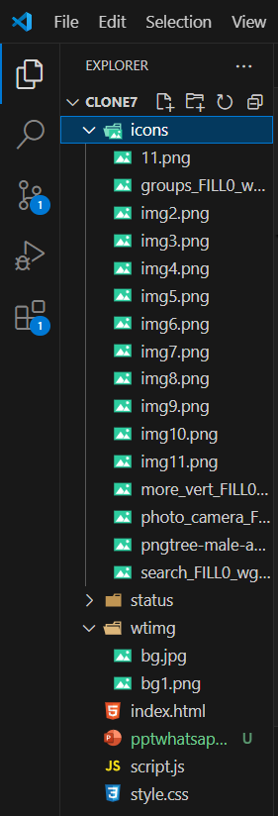

Figure 3.1: File Structure for the Project

1. **index.html**
   * This is the main HTML file that serves as the entry point for the application. It contains the basic structure of the webpage, including the chat interface, sidebar, chat window, and input area.
2. **css/styles.css**
   * This file contains all the CSS styles for the application. It defines the layout, colors, fonts, and responsive design rules. Styles are applied to various elements within the HTML file to achieve the desired look and feel.
3. **js/script.js**
   * This JavaScript file contains the logic and functionality of the application. It handles user interactions (sending messages, displaying messages in the chat window, etc.), manages data storage (using localStorage), and updates the UI dynamically.
4. **images/**
   * This folder is intended for storing any images, icons, or graphical assets used in the application. For example, you might store user avatars or decorative images here.
5. **README.md**
   * This markdown file provides an overview of the project, including instructions on how to set it up, features, and any other relevant information. It serves as documentation for anyone who might work on or use the project.
6. **.gitignore**
   * This file specifies which files and folders should be ignored by Git when committing changes. Common entries might include node_modules/, *.log, or temporary files that do not need to be tracked.

**Setup Instructions**

1. **Create Project Folder**: Create a folder named whatsapp-clone on your local machine.
2. **Create Subdirectories**: Inside whatsapp-clone, create subfolders named css, js, and images.
3. **Create Files**: Create the index.html, styles.css, script.js, README.md, and .gitignore files as outlined in the file structure.
4. **Initialize Git Repository**: Open a terminal or command prompt, navigate to the whatsapp-clone directory, and run the command git init to initialize a Git repository.

**Development Workflow**

* **Write Code**: Use your text editor to write the HTML, CSS, and JavaScript code in the respective files.
* **Test in Browser**: Open index.html in your web browser to see your changes live. Refresh the browser to see updates after making changes to the code.
* **Version Control**: Use Git to track your changes. Regularly commit your changes with meaningful messages to maintain a history of your project development.

## 3.3 Core Components

1. **Main Chat Interface (index.html)**
   * **Chat Window**:
     + Displays messages in a scrollable area, showing the chat history between users. Each message is formatted as a chat bubble, including the message text and timestamp.
   * **Input Area**:
     + Contains a text input field for users to type their messages and a button to send them. The input field supports keyboard interactions (e.g., pressing Enter to send messages).
2. **Sidebar (index.html)**
   * **Contact List**:
     + A vertical list of contacts or chat threads on the left side of the interface. Each contact can be clicked to switch between different chats, displaying the corresponding chat history in the chat window.
3. **Message Object (JavaScript)**
   * A JavaScript object to encapsulate the properties of a message, such as:
     + **Sender**: Identifies the user who sent the message.
     + **Text**: Contains the actual message content.
     + **Timestamp**: Records the time the message was sent.
   * This object can be used to manage and store messages more effectively.
4. **Local Storage Manager (JavaScript)**
   * Handles the saving and retrieving of messages using the localStorage API.
     + **Save Messages**: Stores messages when they are sent, allowing temporary persistence across page refreshes.
     + **Load Messages**: Retrieves and displays stored messages when the application is opened.
5. **Event Handlers (JavaScript)**
   * Manages user interactions through JavaScript event listeners:
     + **Send Message**: Listens for click events on the send button and keypress events in the input field, triggering the function to send messages.
     + **Switch Chats**: Listens for clicks on contact names in the sidebar to load corresponding chat histories.
6. **CSS Styling (styles.css)**
   * Defines the visual presentation of all components, including:
     + **Layout**: Uses Flexbox or Grid to structure the chat window and sidebar.
     + **Styling**: Sets colors, fonts, margins, paddings, and other properties to match WhatsApp’s design aesthetic.
     + **Responsive Design**: Includes media queries to ensure the application is usable on different screen sizes.
7. **Animation Effects (styles.css & JavaScript)**
   * Provides CSS transitions and animations for UI components, enhancing user experience by:
     + **Message Entry**: Applying smooth animations when messages are added to the chat window.
     + **Button Effects**: Adding hover effects to buttons for better interactivity.
8. **Loading Indicator (Optional)**
   * A visual cue (like a spinner or loading animation) that can be displayed when switching chats or sending messages to enhance perceived performance.

**Overview of Interactions**

* **User Interaction**:
  + Users type messages in the input field and send them. The event handlers capture these actions and update the chat window accordingly.
* **Data Flow**:
  + When a message is sent, it is stored in a message object, displayed in the chat window, and saved in local storage for persistence.
* **Chat Switching**:
  + Users can click on contacts in the sidebar to switch between different chat threads, with the corresponding messages being loaded into the chat window.

**Chapter 4**

# Implementation

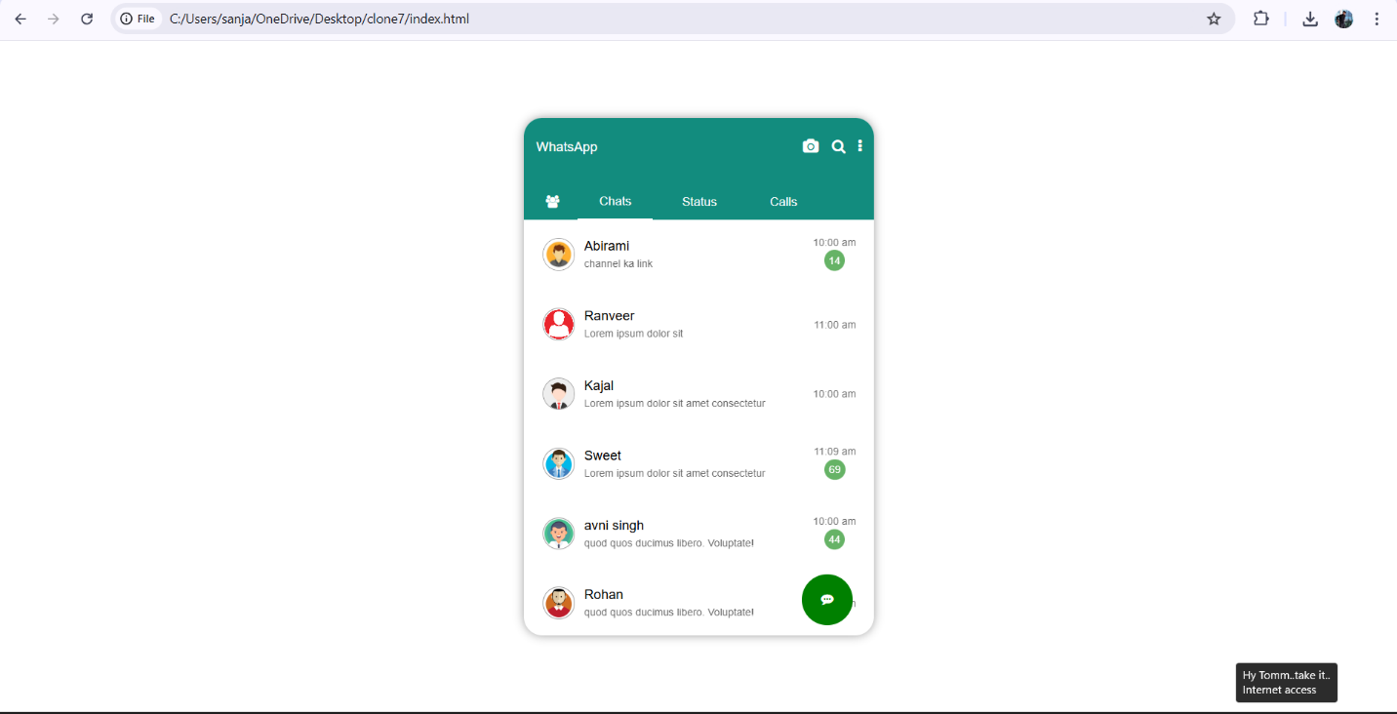

Figure 14.1 what's app clone

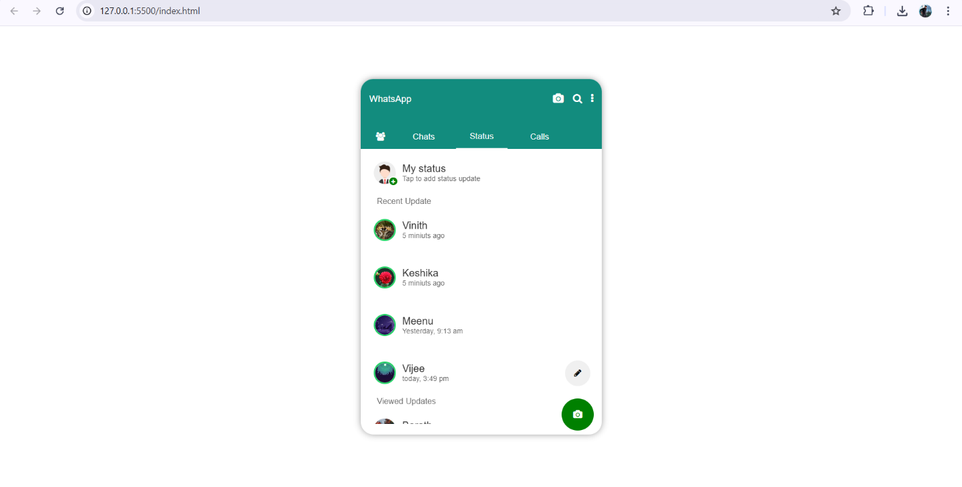

Figure 24.2 Status Bar

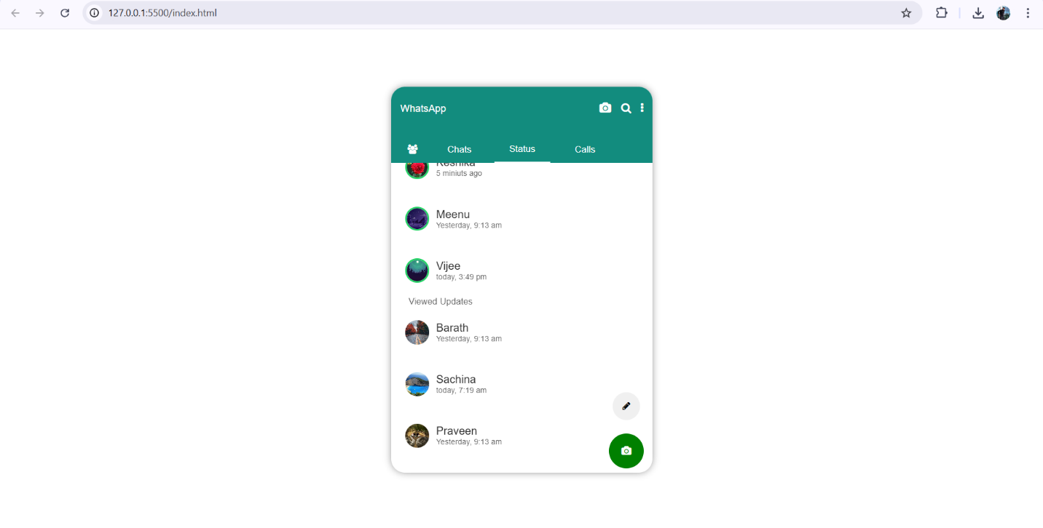

Figure 3 4.3 Updated Status Bar

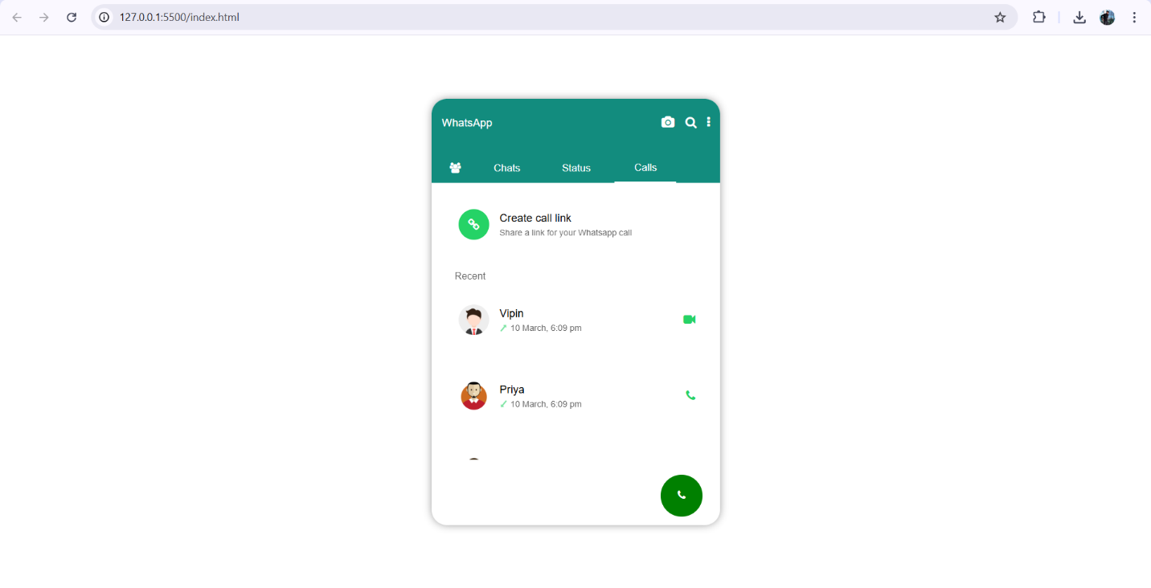

Figure 4 4.4 Call Logs

**Chapter 5**

# Challenges Faced

**Designing a Responsive Layout**

* **Challenge**: Creating a layout that looks good on both desktop and mobile devices required careful consideration of CSS styles, media queries, and component arrangements.
* **Solution**: Used CSS Flexbox and Grid layout systems to create a flexible and responsive design. Regularly tested the application on various screen sizes to ensure usability.
* **Lesson Learned**: Early and frequent testing on different devices helped identify layout issues before they became more difficult to resolve.

**Implementing Real-Time Messaging**

* **Challenge**: Integrating real-time messaging functionality added complexity, especially in ensuring that messages were sent and received instantly without refreshing the page.
* **Solution**: Used Socket.IO to handle real-time communication between the client and server, allowing messages to be sent and received seamlessly.
* **Lesson Learned**: Understanding WebSocket protocols and asynchronous programming was crucial for implementing real-time features effectively.

**Managing State and Data Storage**

* **Challenge**: Ensuring that messages were retained during page refreshes and managing the application state posed difficulties, especially with local storage limitations.
* **Solution**: Implemented local storage for temporary message retention, along with a backend database (MongoDB) for permanent storage of chat histories.
* **Lesson Learned**: Balancing local and server-side storage helped optimize performance and user experience, and understanding the limitations of each storage method was important.

**User Authentication and Security**

* **Challenge**: Implementing secure user authentication and protecting sensitive data from unauthorized access required careful planning and implementation.
* **Solution**: Used JWT (JSON Web Tokens) for user authentication, ensuring that tokens were securely stored and verified on the server. Validated user inputs to prevent security vulnerabilities.
* **Lesson Learned**: Prioritizing security from the beginning is essential, as it can save time and effort later on. Understanding security best practices is crucial for any web application.

**Debugging and Testing**

* **Challenge**: Identifying bugs and ensuring the application worked as intended in different browsers and devices required thorough debugging and testing.
* **Solution**: Utilized browser developer tools for debugging and employed console logs to trace issues. Conducted cross-browser testing to ensure compatibility.
* **Lesson Learned**: Regular testing and debugging during development rather than waiting until the end of the project can help catch and fix issues early.

**Performance Optimization**

* **Challenge**: As the application grew, performance issues such as slow loading times and unresponsive UI components became apparent.
* **Solution**: Implemented performance optimizations, such as lazy loading of messages and optimizing images. Used efficient data retrieval methods to minimize loading times.
* **Lesson Learned**: Regularly profiling application performance can help identify bottlenecks, and planning for performance from the outset is beneficial.

**Learning Curve with New Technologies**

* **Challenge**: Working with new technologies like Socket.IO, MongoDB, and JWT posed a learning curve and required additional time to understand their usage.
* **Solution**: Invested time in tutorials, documentation, and small experiments to get familiar with these technologies before integrating them into the project.
* **Lesson Learned**: Taking the time to learn new tools and technologies is valuable, as it enhances skills and makes implementation smoother.

**Chapter 6**

# Future Improvements

**User Authentication Enhancements**

* **Social Media Login**: Integrate social media authentication (e.g., Google, Facebook) for easier login options.
* **Password Recovery**: Implement a password recovery feature to help users regain access to their accounts if they forget their passwords.

**Backend Integration**

* **Database Enhancements**: Migrate to a more robust database solution (like PostgreSQL or Firebase) for better scalability and management of user data and chat histories.
* **RESTful API**: Develop a comprehensive RESTful API to manage user accounts, messages, and groups more efficiently.

**Real-Time Features**

* **Typing Indicators**: Add typing indicators to show when a user is typing a message, enhancing the chat experience.
* **Read Receipts**: Implement read receipts (e.g., "seen" status) to inform users when their messages have been read.

**User Experience Improvements**

* **Customizable Themes**: Allow users to choose different themes or color schemes for the chat interface to personalize their experience.
* **Emoji and File Sharing**: Add functionality for users to share emojis, images, and files, making conversations richer.

**Group Chat Functionality**

* **Create and Manage Groups**: Enable users to create group chats, add or remove members, and manage group settings.
* **Group Notifications**: Implement notifications for new messages in group chats, allowing users to stay updated.

**Message Search Functionality**

* **Search Bar**: Introduce a search feature that allows users to quickly find specific messages or contacts within their chat history.
* **Filter Options**: Implement filtering options to view unread messages, starred messages, or messages from specific users.

**Notifications System**

* **Push Notifications**: Integrate push notifications to alert users of new messages when the application is not active or when they are using other apps.
* **In-App Notifications**: Provide in-app notifications for important events, such as mentions in group chats.

**Mobile Application Development**

* **Cross-Platform App**: Consider developing a mobile application using frameworks like React Native or Flutter to reach a broader audience.
* **Offline Mode**: Implement offline capabilities in the mobile app, allowing users to draft messages and view cached chats when they have no internet connection.

**Analytics and Monitoring**

* **User Analytics**: Integrate analytics tools to track user behavior and usage patterns, helping improve the application based on user needs.
* **Error Tracking**: Implement error tracking tools to monitor and address application issues in real-time.

**Security Enhancements**

* **End-to-End Encryption**: Implement end-to-end encryption for messages to ensure that only the sender and recipient can read them, enhancing user privacy.
* **Two-Factor Authentication**: Introduce two-factor authentication (2FA) for added security during the login process.

**Chapter 7**

# Summary

The WhatsApp Clone Project is an endeavor to replicate the core functionalities of the popular messaging application, WhatsApp, allowing users to communicate in real-time through text messages. Built using HTML, CSS, and JavaScript for the frontend, this project provides a user-friendly interface that mimics WhatsApp, enabling users to send messages, view chat histories, and manage contacts effectively.

**Purpose**

The primary goal of the project is to create a functional chat application that incorporates essential features of WhatsApp, focusing on user interaction, data management, and real-time communication. This serves as both a practical application for users and a valuable learning experience for developers.

The WhatsApp Clone Project serves as an educational platform that deepens understanding of web development principles and real-time application architecture. By overcoming various challenges and utilizing modern technologies, the project not only replicates essential functionalities of WhatsApp but also sets the stage for ongoing improvements and scalability, ultimately aiming to create a comprehensive and secure messaging platform for users.

**Chapter 8**

# Acknowledgments

I would like to express my heartfelt gratitude to everyone who contributed to the successful completion of the WhatsApp Clone Project. This project not only provided an opportunity to enhance my web development skills but also deepened my understanding of real-time communication technologies.

**First and foremost, I would like to thank my mentor and instructor**, Lekha Savale Ma’am ,for their unwavering support and guidance throughout the development process. Their insights and constructive feedback were invaluable in shaping the project and overcoming the challenges encountered along the way.

**I also wish to acknowledge my peers and fellow developers** who provided encouragement and assistance during various phases of the project. Collaborating with them helped foster a productive learning environment, and their ideas inspired several features implemented in the application.

**Chapter 9**

# References

For further reading and reference, please consult the following resources:

**Books**

* O'Reilly Media. (2021). Learning JavaScript: Enhancing the Experience of Web Applications. O'Reilly Media.
* McKinsey, T. (2020). Web Development with Node and Express: Leveraging the JavaScript Stack. O'Reilly Media.

**Articles and Blogs**

* WebDev. (2023). Building Real-Time Chat Applications with Socket.IO and Node.js. Retrieved from WebDev